Manipulate a Motif
Name: __________________________________ Period: __________
Date of Absence: ________________
Today’s Date: ______________

READ
In dance and choreography we have a tool called a motif. This is pronounced MOW-Teef. A motif is defined as a distinctive feature or dominant idea in an artistic or literary composition. WOAH! What does that even mean? It basically means that it is a movement or sequence of movements that is a dominant idea in your choreography. There are motifs in every art form. Motif can help give the “glue” that is needed for a dance to make sense together.

In music a common motif that most people will recognize is the theme to “Jaws”. It is short and sweet, yet it is dominant and essential to the piece of music.

In art we have even more distinct motifs that are a little more obvious to the untrained eye.

These are a few good examples of an artistic motif.
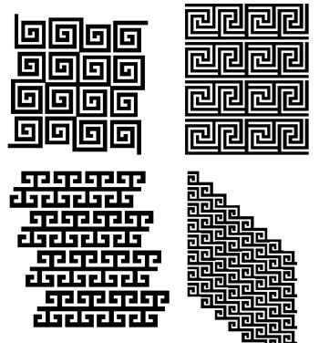

In dance, however our motifs are made up of movement. Yet it is something that is clear and dominant to the choreography. Now that you know what a motif is, we need to talk about how to manipulate it. When you manipulate something it becomes different than the original in some way. In academic dance, we talk about 16 different ways to manipulate a motif. Sometimes this is called theme and variation.

On the next page you will find examples of 8 ways you can change a motif:

8 WAYS TO MANIPULATE A MOTIF:

- Staging - Repeat the same movement on a different place on the stage
- Retrograde - Perform it backward. Start at the end and follow it back through space – like a movie run backward
- Inversion- Upside down ( becomes ) or lateral ( becomes ). For upside- down inversion, you may have to lie on the floor or stand on your head. (This can be tricky and often impossible, but don’t dismiss it on those grounds.)
- Size - Condense / Expand. Take the motif and do it as small as you can. Try it even smaller. Now take the movement and make it bigger, as big as you can.
- Tempo - Fast / Slow / Stop. Take the motif and do it as fast as possible. Try again, even faster. Be careful not to let it get smaller. Do it as slowly as you can. Remember to keep the space constant, the same size it was originally. Find places for stillness in it.
- Rhythm - Vary the rhythm but not the tempo. The variety and pattern of the beats should be altered, not the speed or the length of time it takes to accomplish. If, for example, the original rhythm was η η, try doing it iq q η.
- Quality - Vary the ENERGY movement quality. Try the same movement quivery, drifting, with suspended energy, exploding, etc.
- Instrumentation - Perform the movement with a different body part; try several different parts of the body. Let another performer do it. Have a whole group do it.

DANCE
Now choreograph a short motif. NO LONGER THAN 8 COUNTS! Make sure it includes axial and locomotor movement.

Then choose 3 manipulation tools to use and manipulate your motif. List your three choices below.
1. ______________________________
2. ______________________________
3. ______________________________

When you are finished with this assignment, you should have 1 motif, and three manipulations. Please demonstrate ALL of your movement for you teacher and get it passed off.

Teacher Signature: ________________________

